**Notes and Snippets from the Chair**

**Our Christmas theme John Samuel Prichard the original Tailor of Gloucester**

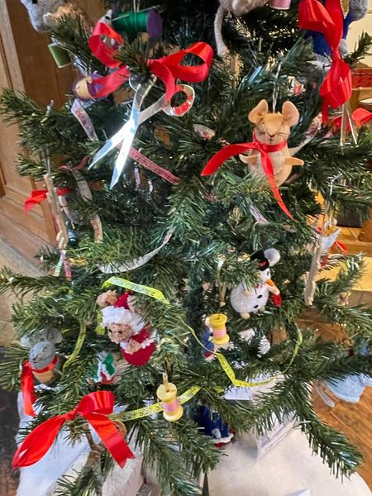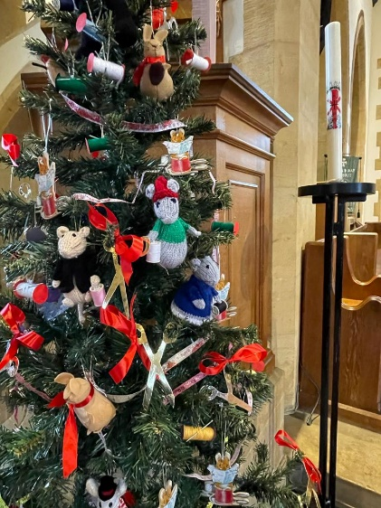

We have created a crowdfunding page to help fund the Memorial Plaque and signpost markers for John Samuel Prichard’s grave. Please support this project, no donation is too small.

**You can find our crowd funding page at**

<https://www.justgiving.com/crowdfunding/tailor-of-gloucester>

The plaque will be the same size as the CWGC sign and be situated next to it at the entrance to the Charlton Kings Cemetery. We have the date of his death as 24th February 1934, but are awaiting confirmation of his birth in January 1877. We are planning the unveiling of the plaque on 2nd March 2024, more details to follow.

s I finish my Snippets for 2023. The committee members and I would like to wish you all a very Merry Christmas and a Joyous New year.

**A**

**Message from Mags, Membership Secretary**

Our thanks to you all for your support during 2023. We now have 44 members, having lost a few and have increased by 25%.

**Rebecca, CKLFS Secretary**

Rebecca has just started her new job at Historic England working with the Policy and Evidence department. As part of her role, Rebecca and her team oversee contributions to [The Missing Pieces Project](https://historicengland.org.uk/listing/missing-pieces/). This is an opportunity for the public to share photos or stories about the designated listed buildings in their local area.

You can find the listed buildings in Charlton Kings on the [National Heritage List for England](https://historicengland.org.uk/listing/the-list/) and submit your memories or images about these historically and architecturally significant buildings to help build a national picture of our important historic environment.

If you would like to find out how you can contribute, then please contact Rebecca direct rhksnook@gmail.com or [customers@HistoricEngland.org.uk](mailto:customers@HistoricEngland.org.uk).

**Meetings 2024**

**Forthcoming Events**

**All at the Stanton Room unless otherwise stated**

**2pm to 4 pm tea and coffee available**

26th March - AGM plus speaker TBC

23rd April - Rural Policing in Gloucestershire by Sue Webb

28th May - John Nevil Maskelyne - Gloucestershire Master of Magic and Mystery by Andy Meller.

25th June - Roberts Brothers of Gloucester-Games makers to the Empire by Malcom J Watkins

July Visit to Gloucestershire Archives provisional - TBC

27th August - The Quarries and the Tramroads of Leckhampton Hill By Dr Ray Wilson

24th September - The lost Railways of Gloucestershire by David Aldred

22nd October - History of Highwaymen and highway robbery in Gloucestershire by John Putley

26th November - Art of Dowsing by the Cheltenham Dowsers group by Ken Fheather